**Yummify**

**Team**: 2^5

**Members:**

Jugariu Diana

László Denisa

Marcu Paul (Boss)

Moisiuc Claudia Ioana

Molnar Andreea Patricia

**Coordinator**: Agota Radoi

**Project Description ~ Sales Pitch**

Since the beginning of time, eating has been a necessity. However, as time went on, people sought to make it into a more delightful experience. Unfortunately, not everybody has the time, the budget, or the knowledge to enjoy cooking. Because of this, we have made a platform where people can share recipes and attempt to learn to cook new foods that match their taste. Our site helps people find recipes that match their budget, time constraints, desired calorie intake, and other criteria. It also has some features for people who prefer having their information accessible in a more analog format, such as downloading recipes in various formats suitable for offline access or printing. If this piqued your interest, we urge you to give it a try.

**Task Management**

For managing the application development, our team used GitHub as the primary platform for code collaboration and version control. Our main focus was primarily code synchronization and ensuring seamless collaboration among team members.

To maintain transparency and foster collaboration, we held weekly meetings where team members shared their progress and discussed any challenges encountered during the development process.

**Used Technologies**

Below we have provided a short description of the technologies used in the development process, in addition to that we also provided our reasoning for using that particular framework/language.

**BackEnd:**

* Python
  + Python was chosen as the backend programming language for its versatility, readability and for the fact that we were all equally familiar with it.
* *Django REST Framework*
  + Django (high-level Python web framework) was instrumental in expediting the development of our backend. Its automatic admin interface significantly reduced boilerplate code and accelerated the implementation of core functionalities.
* *SQLite*
  + The inclusion of SQLite in the Django framework provided a straightforward and effective solution for managing the project's database needs without the need for additional configuration or external dependencies.

**FrontEnd:**

* *React + TypeScript*
  + React's component-based architecture facilitated the creation of modular and reusable UI elements, promoting maintainability and scalability.
  + TypeScript added an extra layer of robustness to our codebase by providing static type checking, catching potential errors during development and enhancing code clarity.
* *CSS + HTML*
  + For styling and structuring the frontend, we went with the classic combination of CSS and HTML. CSS provided the means to design visually appealing and responsive user interfaces, while HTML formed the backbone for structuring content.
* *NPM*
  + NPM allowed us to easily install and manage libraries, frameworks, and tools needed for our frontend development.

**Diagrams**

* *Database Diagram*

This is the relevant portion of the diagram, we have also attached the full version of the diagram at the end in case of complaints. :)

This is an auto-generated diagram so the full version contains all classes Django uses to create and manage users.

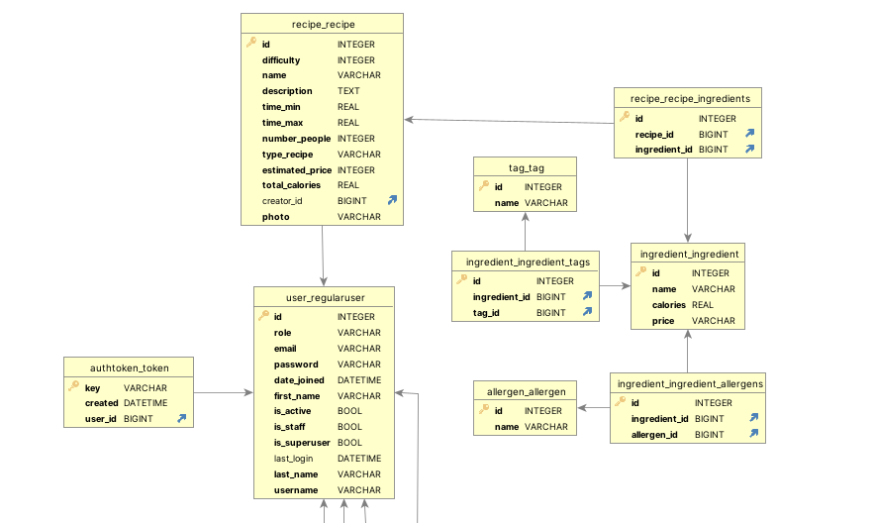

* *Class Diagram*

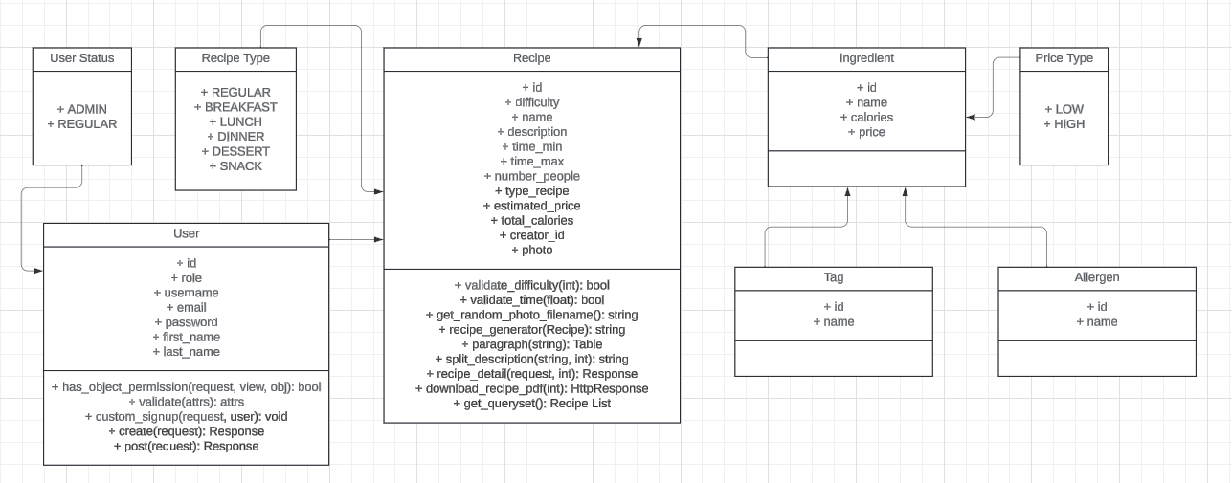

* *Use case diagram*

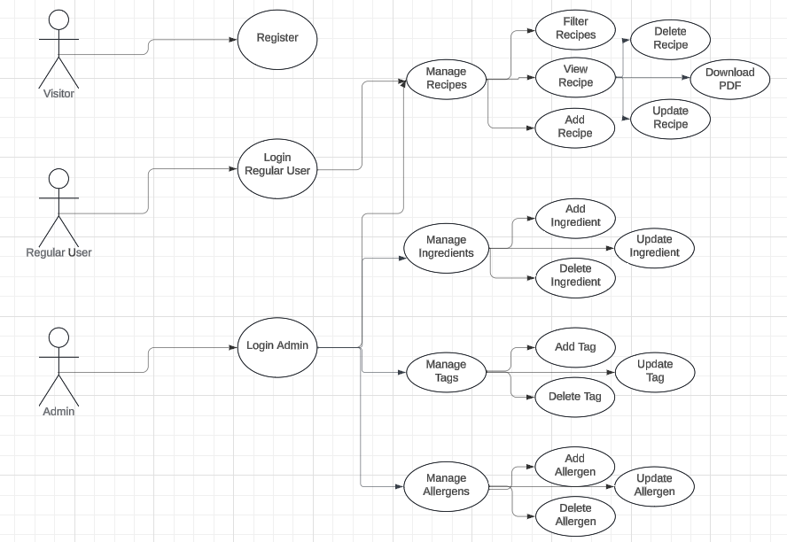

**Short Demo - Help Manual**

* *Register*

*In order to access our website you need to have an account. In order to create an account you need to complete all the text fields (yes you need a strong password, no “1234” will not work), after that you press “Sign Up” and you’re done.*

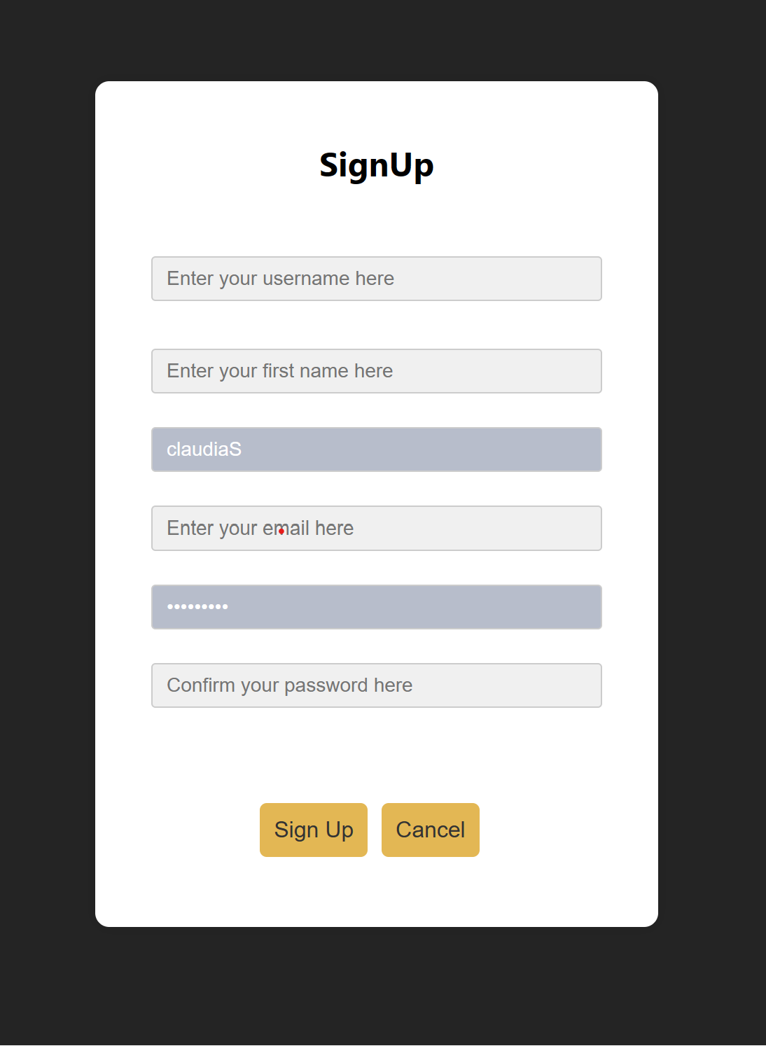

* *Login*

*The user needs to fill in their “username” and “password”, after that they can press “Log In”.*

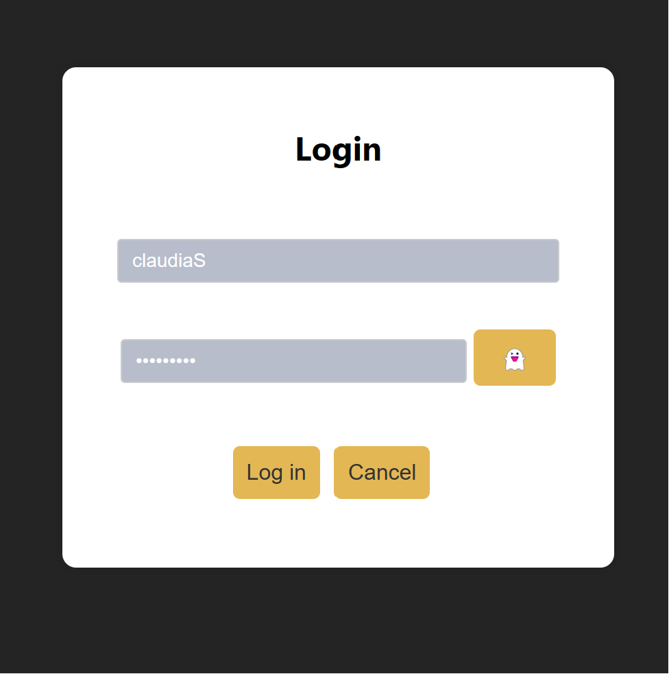

* *Main Page + Filters*

*After the user is logged in, they can access all the recipes in our database. In order to filter recipes you need to press the “Filter” button and select the categories you want to filter by.*

*You can also only see recipes you created by pressing the “Your Recipes” button.*

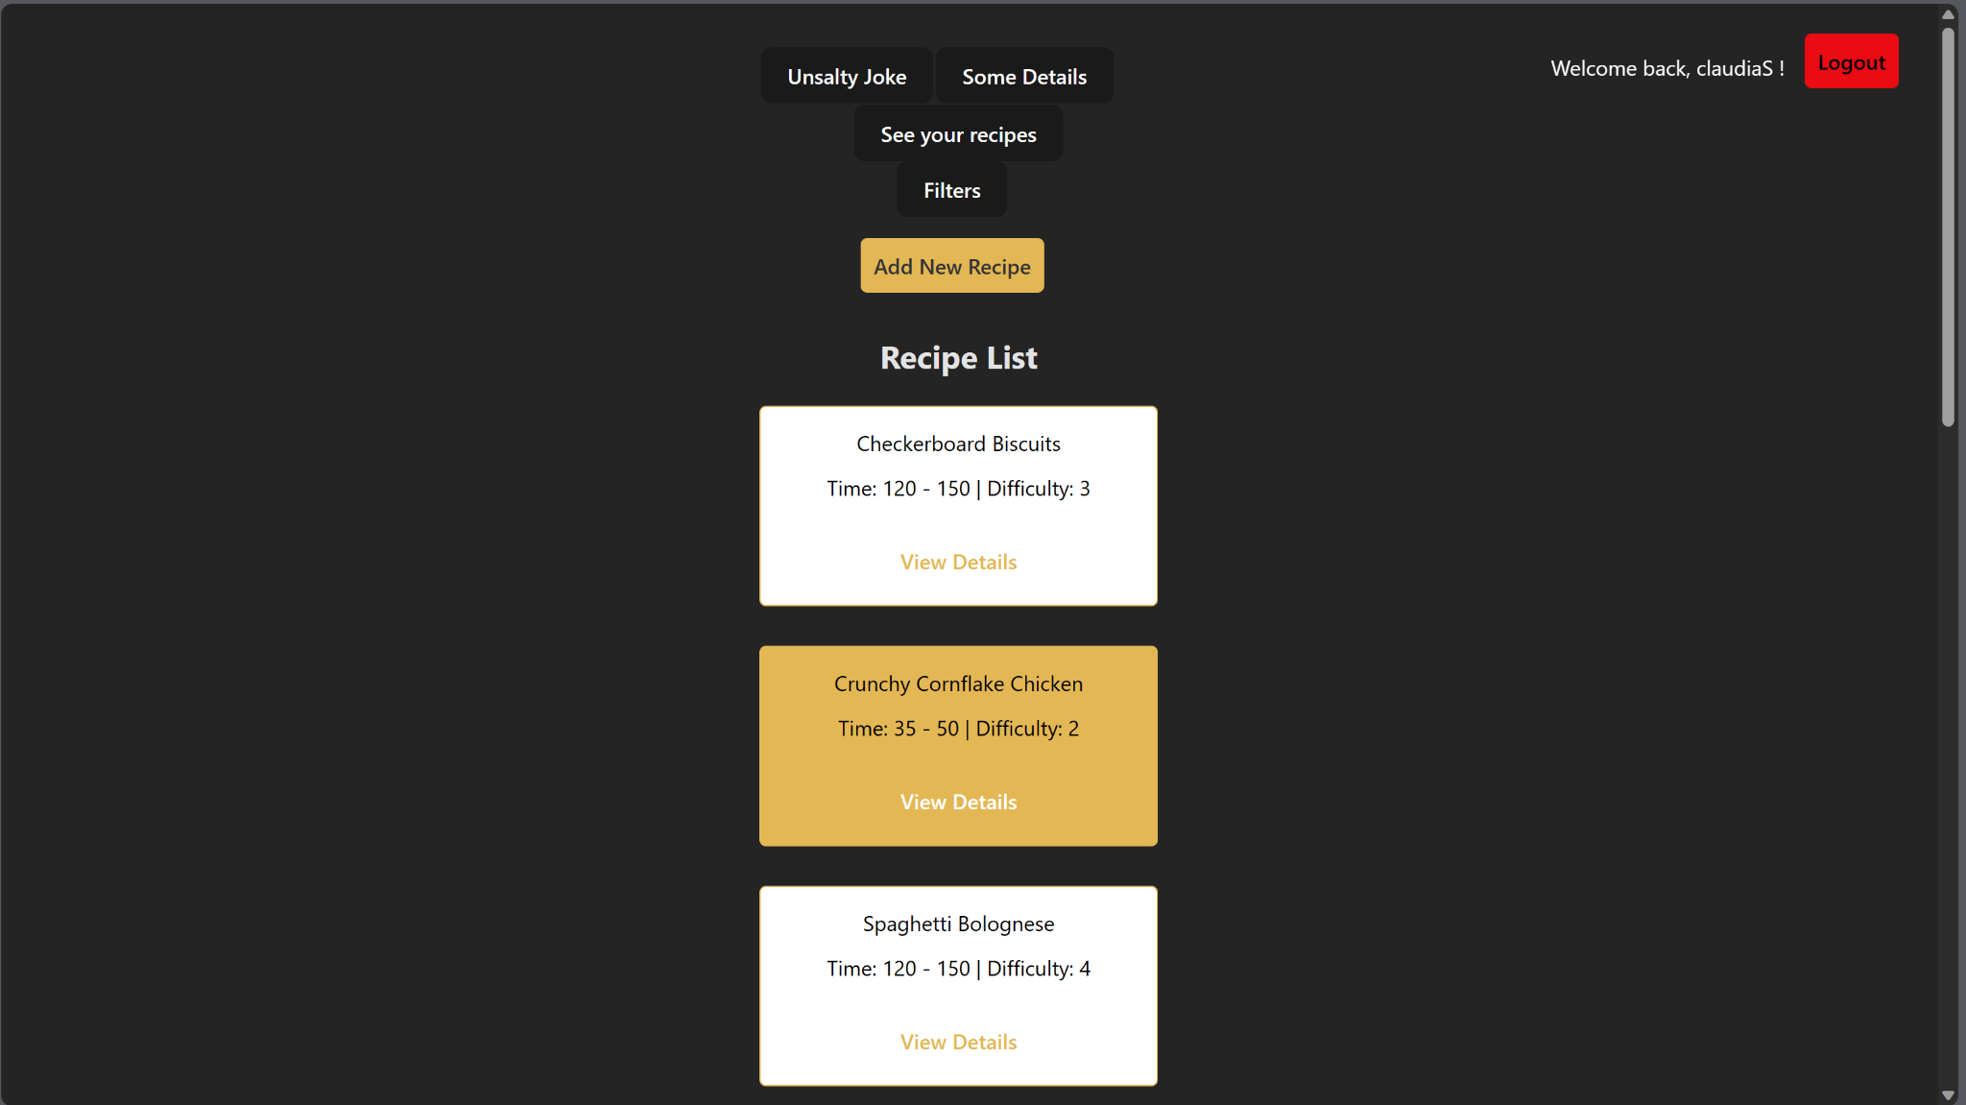

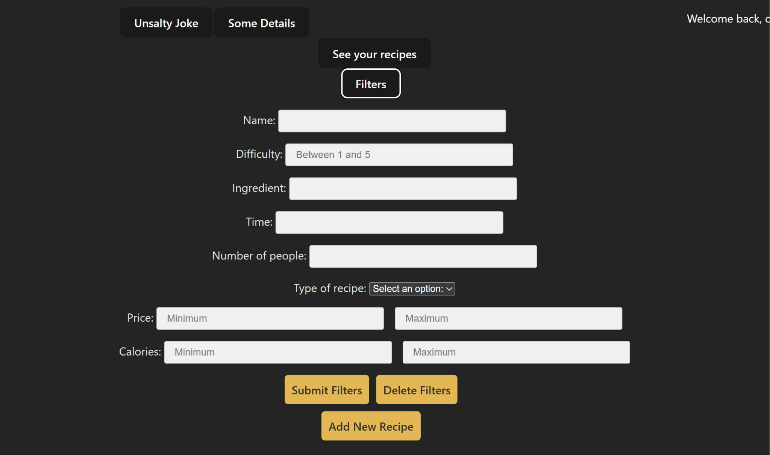

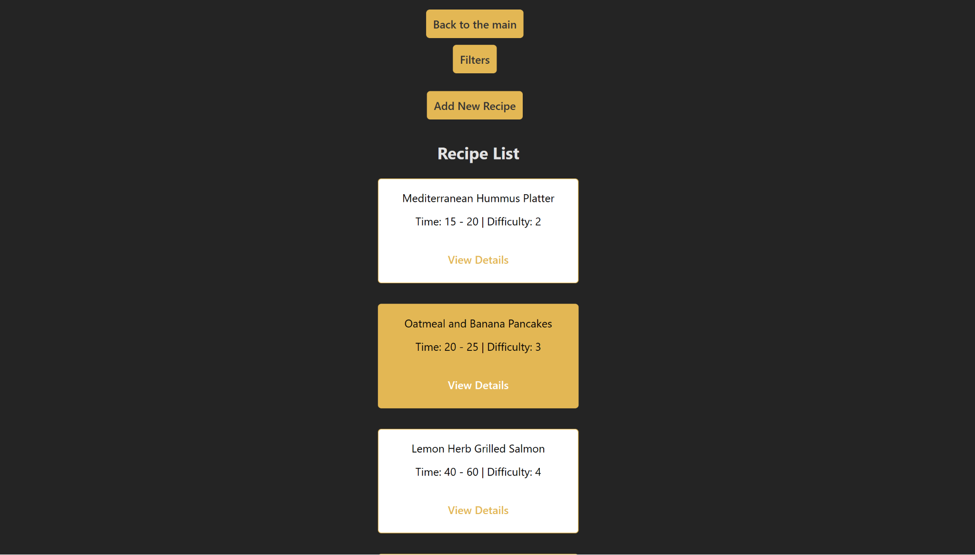

* *Add Recipe*

*Click the “Add Recipe” button and fill in the required text fields.*

*A recipe has the following properties:*

* + *Difficulty:*

*a number between 1 and 5, depicting the difficulty of the recipe*

* + *Name:*

*what the recipe is called*

* + *Description*

*a short description of how to prepare the recipe*

* + *Time min*

*the minimum amount of time required for a recipe to be completed from users perspective*

* + *Time max*

*the maximum amount of time required for a recipe to be completed from users perspective*

* + *Number of people*

*how many people this recipe could feed :)*

* + *Estimated price*

*how much all this can approximately cost*

* + *Total calories*

*this field is for our die-hard gym bros out there, you can guess by its name what its supposed to be*

* + *Ingredients*

*input a list of ingredients used in this dish*

* + *Recipe type (not required)*

*the user can choose between: breakfast, lunch, dinner, dessert or snack*

*it will automatically be assigned as “regular” if the user doesn’t pick one of the above options*

* + *Photo (not required)*

*the user can add a photo of the final dish, if they don’t it will randomly choose one from our predefined pool of random food related pictures*

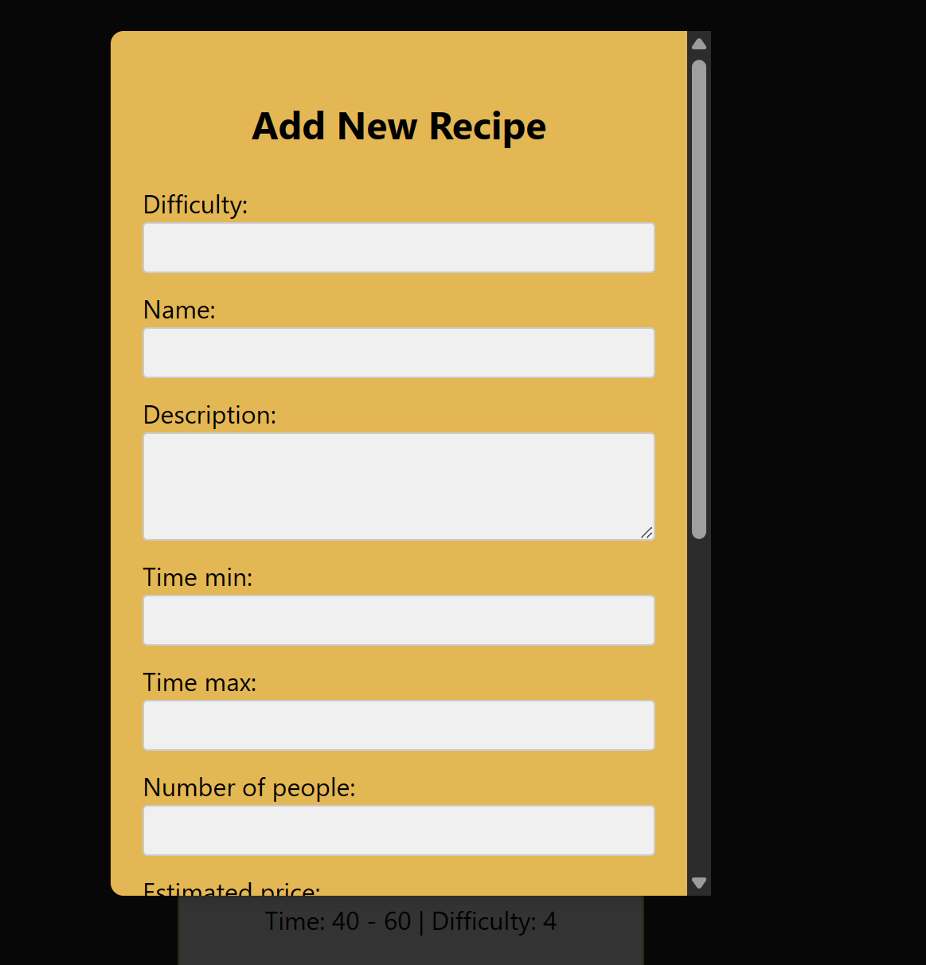

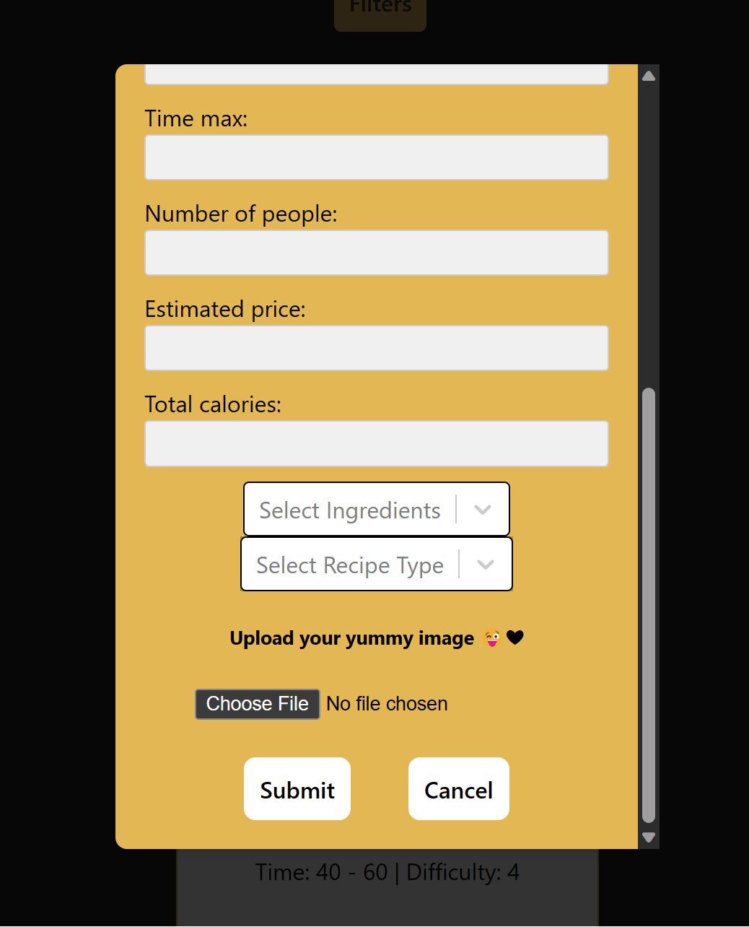

* *View Recipe Details + Generate PDF*

*On the main page, the user can see a recipe’s details if they press “View Details”.*

*In order to generate a PDF of the recipe you can press “Generate PDF”.*

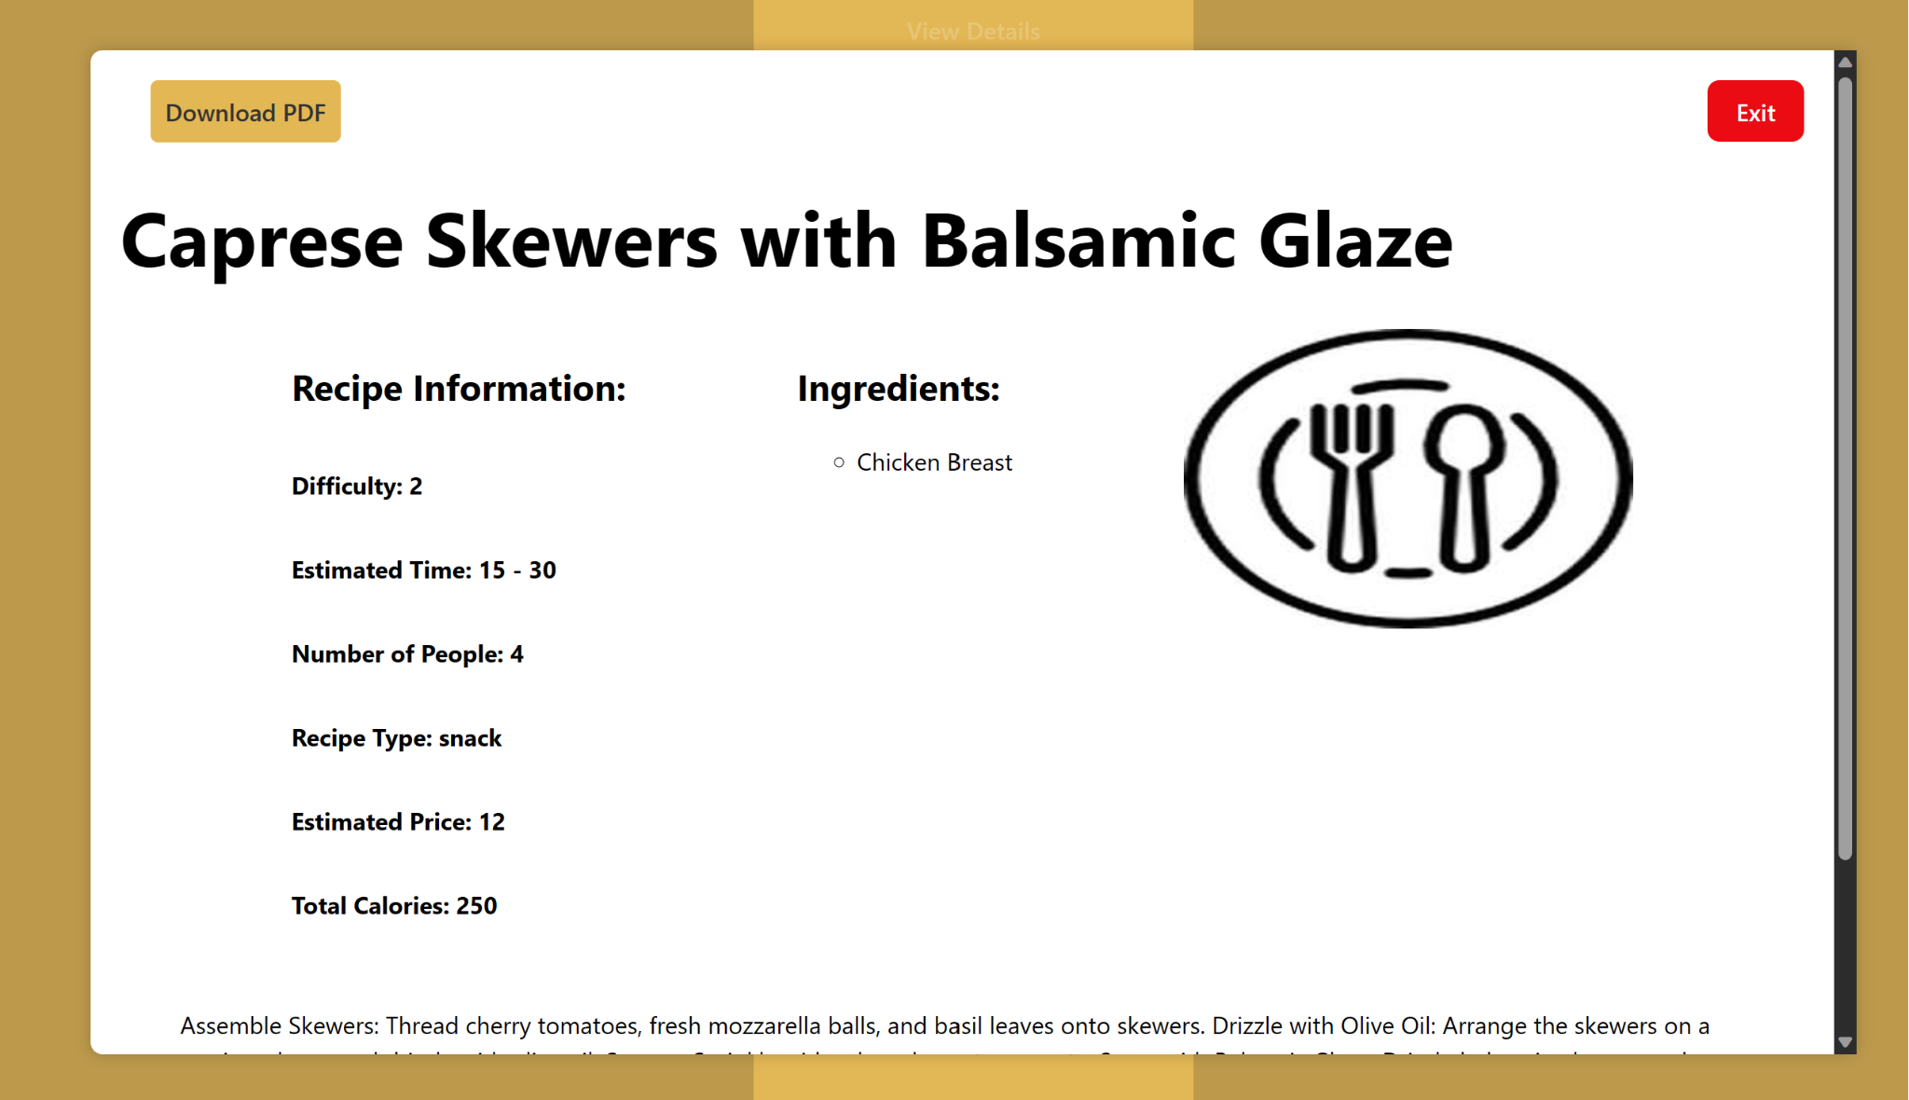

* *Update Recipe*

*To update a recipe, press the “Update”, modify the fields you want to change and press “Submit”. If you change your mind press “Cancel”.*

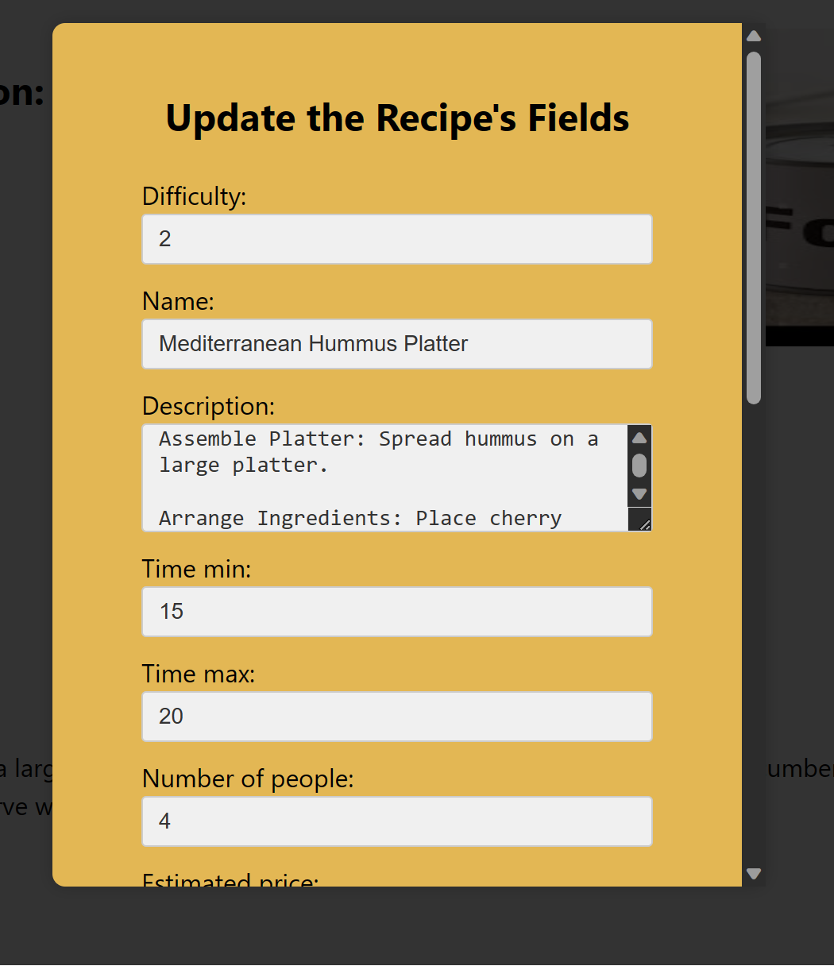

* *Remove Recipe*

*To remove a recipe, press the “Remove” button on the recipe’s details page.*

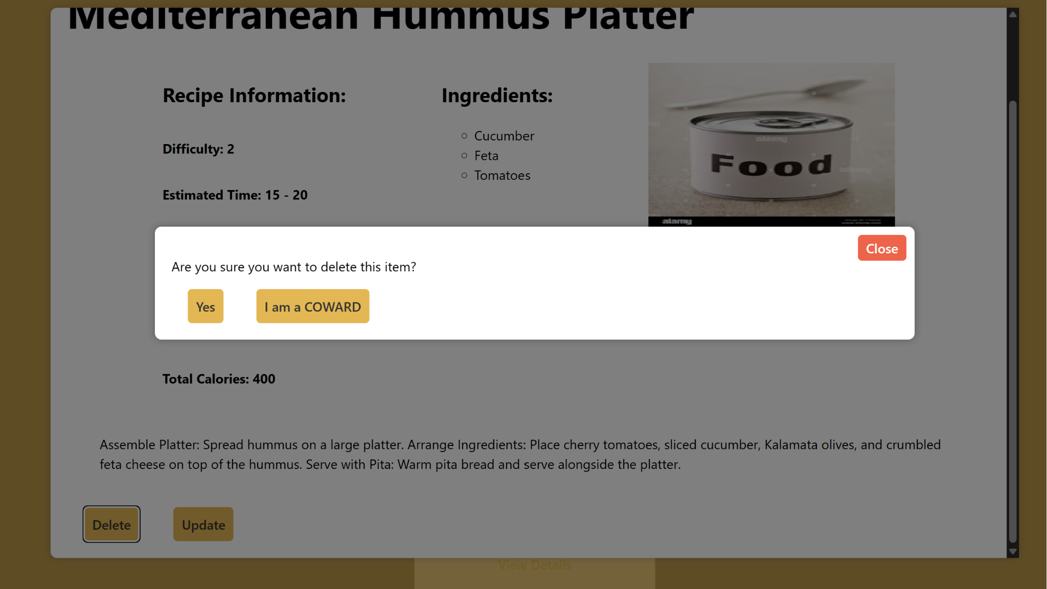

Memes at the end for sympathy.   
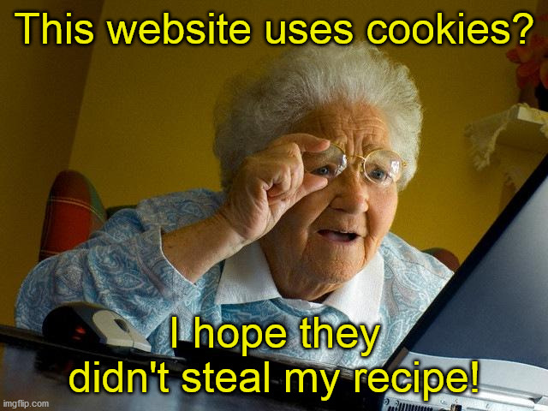

**Full Version Database Diagram**

I believe that this is truly useless information for the general public, the other diagram is more straight-forward.

